INTERNATIONAL CONSULTING CONTRACT TEMPLATE

The International Consulting Contract is a type of agreement typically used by international consulting firms or professionals that work in international markets, and where one of the parties (Consultant) establishes the conditions of its services proposal to the other party (Client). These contracts are usually used for a specific project within a wide range of areas (management, market research, human resources, corporate strategy, engineering, IT, etc.) In the most important aspects of the International Consulting Contract (fees and expenses, Intellectual Property Rights, applicable law and competent jurisdiction, etc.) a number of alternatives have been provided, for the most appropriate one to be selected according to who drafts the contract (Consultant or Client).

INTERNATIONAL CONSULTING CONTRACT

DATE: .............................................................................................................................................

BETWEEN:

Alternative A [When the Consultant is a company]

................................. [company legal name] whose registered office is at ..................................... [address, city and country] and registration/fiscal number is ............................., represented by
..................................................................... [name and surname, position] (hereinafter referred
to as “the Consultant”),

Alternative B [When de Consultant is an individual and independent professional]

Mr./Ms. …………….., of legal age, ………………...........[include professional qualification], Tax Identification Number………….., registered address ……………, acting on his/her own behalf (hereafter referred to as “the Consultant”),

AND:

................................. [company legal name] whose registered office is at ..................................... [address, city and country] and registration/fiscal number is ............................., represented by
..................................................................... [name and surname, position] (hereinafter referred
to as “the Client”).

Both Parties recognize mutual legal capacity to undertake the obligations of the present Contract and declare that:
- The Consultant has expertise in the field of ………… [describe the activities of the Consultant] ............................... and possesses the knowledge and technical and human resources necessary to provide the services related to that field (hereafter “the Services”).

- The Client has appointed the Consultant to provide the Services on the terms and conditions of this Contract.

- Both parties undertake to observe the following Consulting Contract:

CONSULTING SERVICES

The scope of the Services to be provided to the Client by the Consultant is set out in Annex 1. If the Client requires any additional services or any change to the agreed Services, the Consultant will be entitled to an adjustment of the fees and an estimate of the additional fees which may be due will be provided to the Client upon request.

OBLIGATIONS OF THE CONSULTANT

    - The Consultant will perform all his obligations to a good professional standard.

    - The Consultant will dedicate such of his time, attention and resources to providing the Services as may be necessary for its satisfactory and timely competition.

    - The Consultant will keep the Client informed as to the progress of the services provided and, in particular, will promptly give information about progress upon request.

    - The Consultant will comply with all reasonable request and directions of the Client related to de Services, and will comply with all regulations in force in the country of the Client.

SCHEDULE AND DURATION OF THE SERVICES

    - The Consultant will provide the Services in accordance with the timetable table set out in the Schedule of Annex 2.

    - If the commencement date for the Services is not agreed in advance, the Services will be treated as having commenced on the date the Consultant begins to carry out any of the Services to the Client.

    - The Services will continue until they are completed, unless the appointment is terminated early in accordance with the terms of this Contract
............................................................................................................................................

This is a sample of 2 pages out of 7 of the International Consulting Contract To get more information about this contract click here:


INTERNATIONAL CONSULTING CONTRACT

USER GUIDE

Contracts drafted by the legal experts of Global Negotiator cover all relevant aspects that are negotiated and agreed in the different types of business between companies. However, when these contracts are used you should take into account some recommendations common to all of them that are described in this User Guide.

DATE

The date when the contract comes into force is the one that appears in its header, as mentioned in the final paragraphs of the contract, before signatures (This Contract comes into force on the date written above).

In some contracts -for example in the Supply Contract- the date of coming into force is also mentioned in one of the clauses. In these cases you have to verify that the two dates inserted in the contract (in the heading and in the corresponding clause) are the same, in order to avoid discrepancies.

PARTIES

Be sure to insert in the first page of the contract the full details of the Parties:

      - When a Party is a company you must insert the following information: legal name, legal form (limited, incorporated, etc.), full address, registration data and fiscal identification number.

      - When a Party is an individual that works as independent professional (for example a commercial agent) you must insert the following information: full name, profession, full address and fiscal identification number.

CLAUSES

Clauses with different alternatives: choose the most favorable

In the most important clauses of each contract (exclusivity, payment terms, applicable law and competent jurisdiction, etc.) several drafting alternatives are proposed so you can choose the most appropriate to each situation. Therefore, the user before submitting the contract to the other Party must choose the alternatives that seem best suited to their interests, and eliminate the rest.

Clauses with blank spaces to be completed

In several clauses of the contract blank spaces appear with dots (.......................) that the user has to complete inserting text. Following the dots, between brackets, you will see the data and explanations to insert the text.

      - When the text between brackets is in normal letters (the same as the contract) and separated by "," or the word "o", the user must insert one of the options suggested.
Example of blank space (........) with options to select between brackets:

Orders handled before completion of the present Contract which produce sales transactions within .......... [1, 2, 3, 6] months shall entitle the Agent to receive the corresponding commission. In this case the user must choose between options 1, 2, 3 or 6 months and insert one in the blank space (........).

- When the text between brackets is in italics the user has to insert the data and information requested and eliminate the bracketed text.

Example of blank space - (.........) to insert text:

Both parties, by mutual consent, resolve to refer any dispute to the Rules of Conciliation and Arbitration of the International Chamber of Commerce by one or more arbitrators appointed in accordance with said Rules. The place of arbitration shall be ........... [city and country]. In this case the user must insert in the blank space (...........) the city and country chosen to conduct the arbitration and afterwards eliminate the bracketed text [city and country].

Notices Clause

Sometimes it may happen that the official address of the Parties which appear at the beginning of the contract is different from which is to be used for communications between the Parties during the terms of the contract. In this case the user should include at the end of the contract a Notices Clause.

Example of Notices Clause:

Notices. - In order to comply with their contractual obligations, the Parties establish the following address for the provision of notices related to this contract:
- Party 1 ............................................................. [insert full address].
- Party 2 ............................................................. [insert full address].

ANNEXES

The contracts incorporate some Annexes, each of them, referenced to the corresponding Clause. Annexes are drafted in commonly used formats, although the user must adapt these formats and the text inserted in them to each particular situation.

SIGNATURES

People who sign

Persons signing the contract on behalf of the company must have the authority to do so and preferably, be entitled on the basis of a power of attorney. Below the signature, in addition to the full name of the person that signs his/her position must be inserted. When one of the Parties who signs is a natural person (for example a commercial agent in an Agency Contract) obviously he or she is the person that has to sign the contract.
The laws of some countries require that contracts, to be valid, shall be signed in front of witnesses or a public notary. Therefore, before signing a contract you should be informed about the requirements that may exist in each country.

Place and date of signature

Usually contracts are signed by both Parties on the same date and place. Nevertheless, in international contracts, due to physical distance, it is common that each of the Parties sign in different dates and places. This contract provides for both alternatives so it comes to choosing the most appropriate to each situation.

Number of copies

Usually, the Parties sign two copies of the contract, each Party retaining one of them, but can also arise the need to sign more copies. In this case all you have to do is mention explicitly the number of copies to be signed in the paragraph that is included at the end of the contract (Both Parties declare their conformity to the present contract, which is signed in ...... copies, each of which shall be considered an original).

GENERAL RECOMMENDATIONS

The Parties must sign all pages of the contract, including Annexes, so they are also valid. It is better to use ball point or pen (not pencil) in a color other than black (e.g.: blue); this makes it easier to distinguish an original document from a photocopy.

It is preferable (although no mandatory) to express sums of money and percentages in words and figures. Of course, the words and figures for a given amount must match exactly. You also must insert the currency in which the amounts are expressed. It is advisable to use the rules establish by ISO that name each currency by three capital letters (EUR for euro, USD for dollar, GBP for sterling pound, JPY for Japanese yen, etc. - you can get the acronyms of every currency in the website www.oanda.com).

Once you have chosen the best alternatives of each clause and have completed the blank spaces you should revise the whole contract to remove remaining paragraphs and correct any errors.
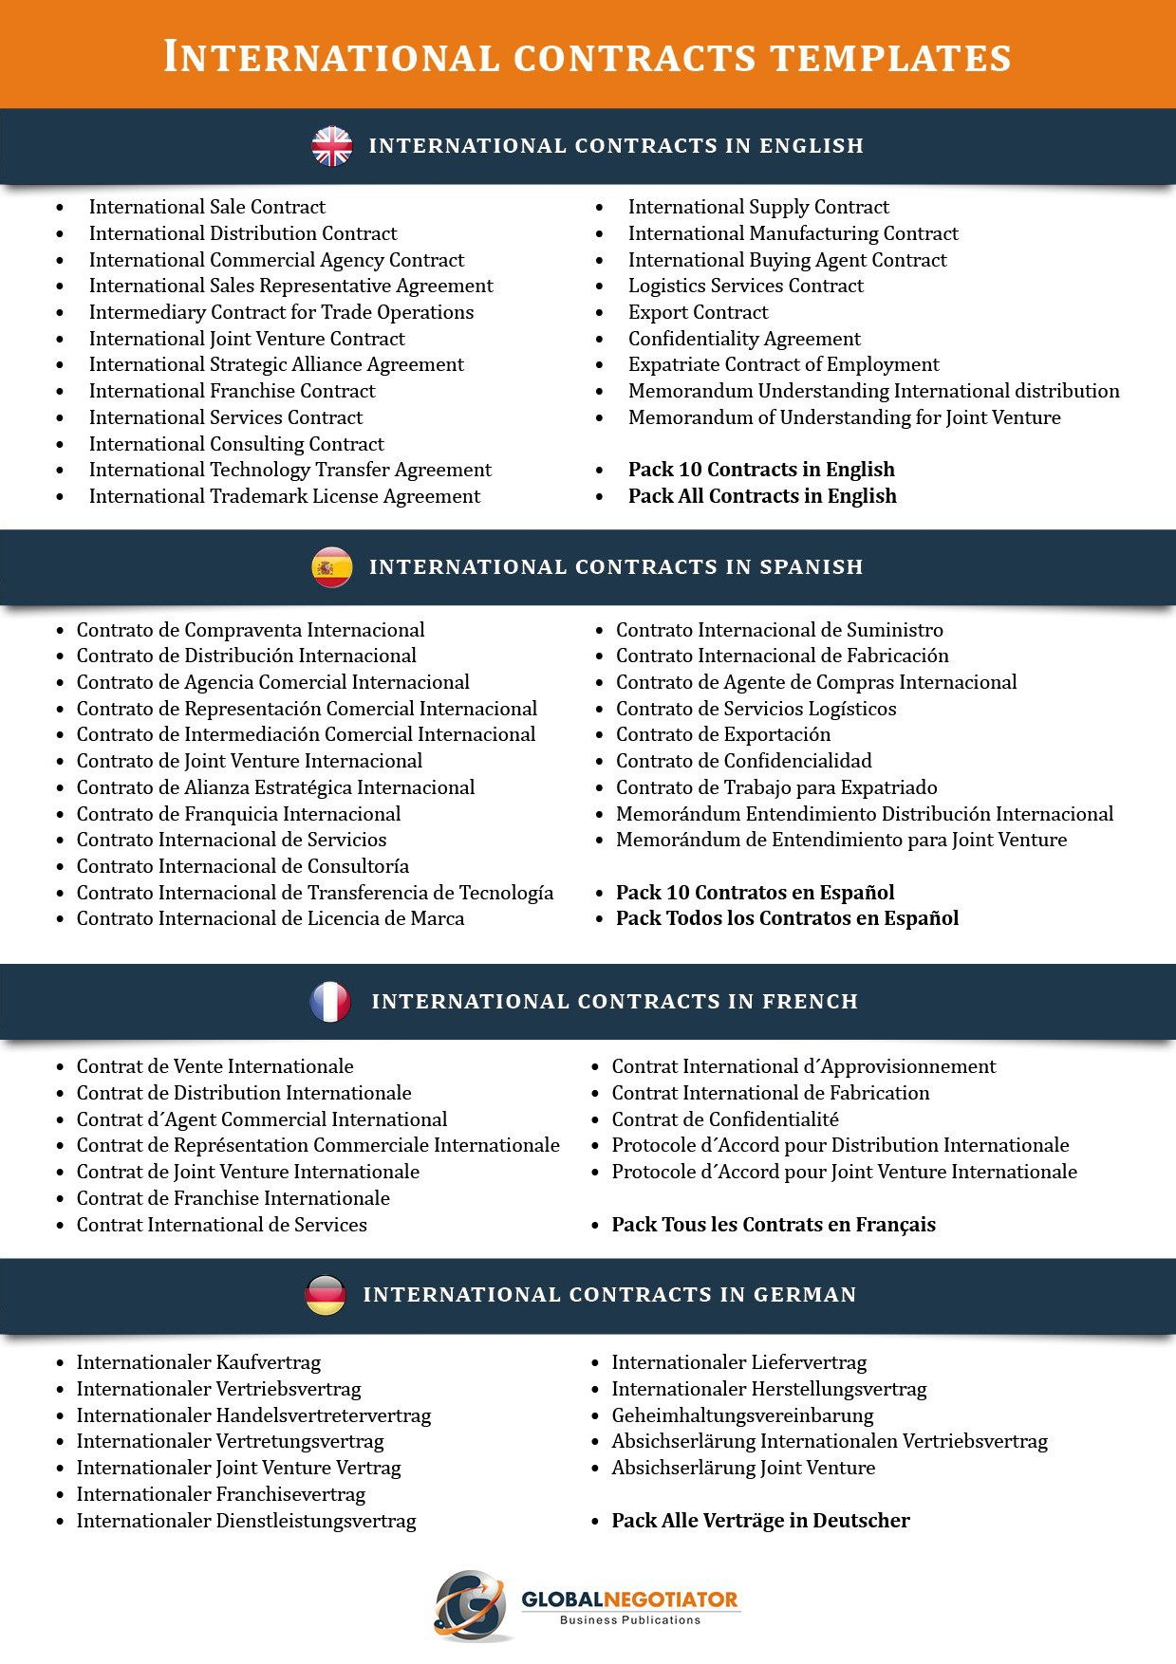

6

